**EBS Volume Modifier**

Project Description:

As a Cloud Engineering team we take care of the AWS environment and make sure it is in compliance with the organizational policies. We use AWS cloud watch in combination with AWS Lambda to govern the resources according to the policies. For example, we Trigger a Lambda function when an Amazon Elastic Block Store (EBS) volume is created. We use Amazon CloudWatch Events. CloudWatch Events that allows us to monitor and respond to EBS volumes that are of type GP2 and convert them to type GP3.

When we try Create a EBS Volume Whatever its type WE mentioned while Creation it will converted to ‘GP3 ‘ .

Process of Creating Resources

1. Creating Lambda Function to Convert EBS Volume to Required type

And create new IAM Role to Lambada Function.

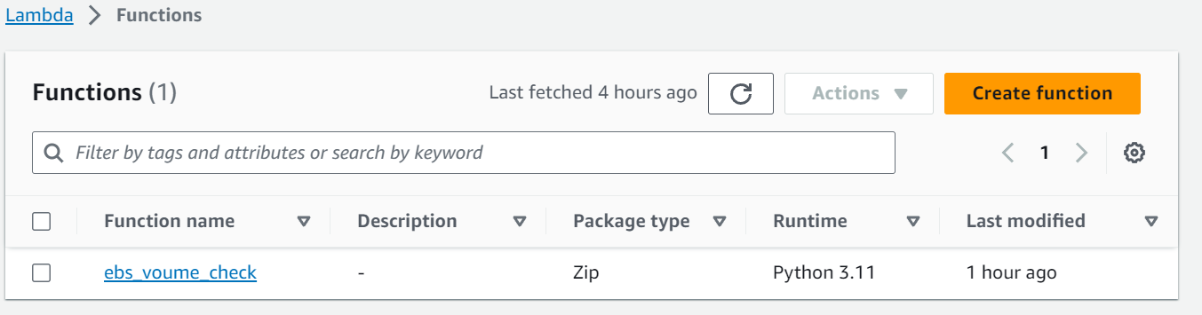

1. Create a Rule Under Events In The Cloud Watch Logs To Trigger when Ever The EBS is Created

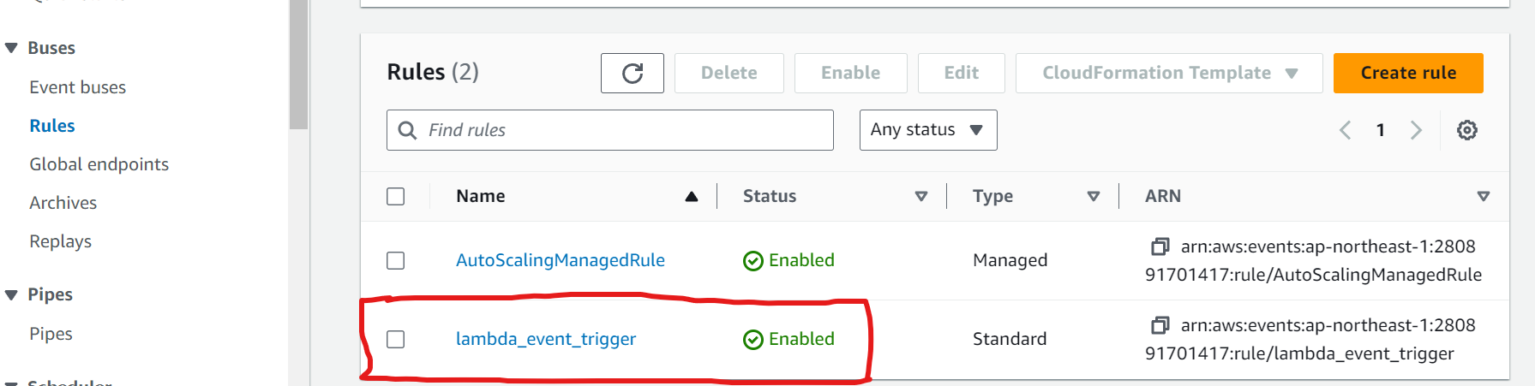

1. Add Rules in the Event like Event Volume creation example of Event Pattern:

{

"source": ["aws.ec2"],

"detail-type": ["EBS Volume Notification"],

"detail": {

"event": ["createVolume"]

}

And Add Target as Lambda Function

1. Add In-Line Policy to the IAM Role Created in Process of Creation of Lambda   
   attached polices of Role is
2. AWSLambdaBasicExecutionRole
3. Ebs _vol_check inline Policy of permissions having

Describe Volume,Modify Volume

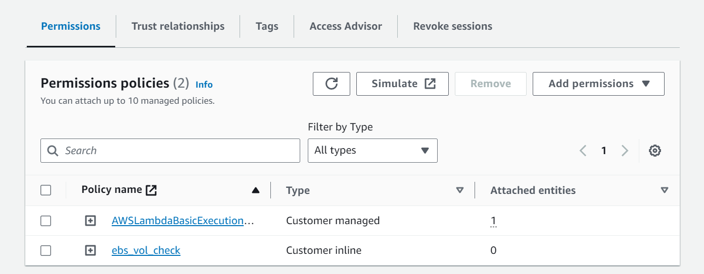

1. Write Code in the Lambda Function to change volume using ‘boto3’ Module

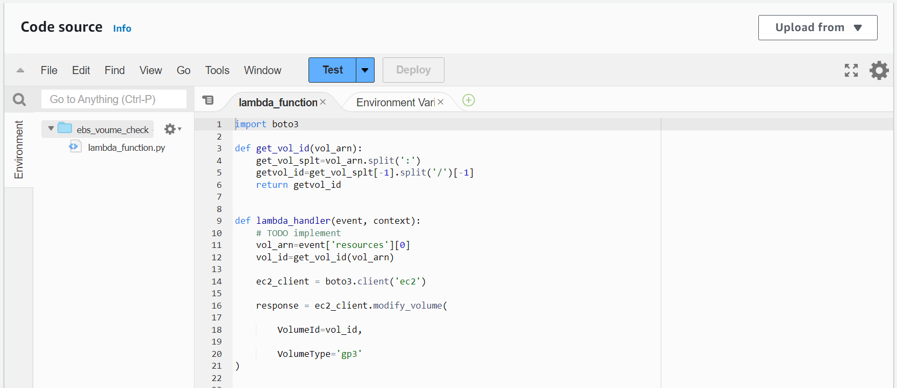

1. Code for changing Volume type

##code for Lambda Function

import boto3

def get_vol_id(vol_arn):

# splitting arn and returning ‘volume_id’

get_vol_splt=vol_arn.split(':')

getvol_id=get_vol_splt[-1].split('/')[-1]

return getvol_id

def lambda_handler(event, context):

# getting ARN of EBS Volume Through EVENT that is getting by Cloud Watch Logs

vol_arn=event['resources'][0]

# getting the Volume ID by passing ARN to the Above Function

vol_id=get_vol_id(vol_arn)

# here assigning client to a Variable

ec2_client = boto3.client('ec2')

# modifying the Volume type using BOTO3

response = ec2_client.modify_volume(

VolumeId=vol_id,

VolumeType='gp3'

)

1. Finally Testing Our Setup

Create a EBS Volume (or) Launch an Ec2 Instance of type Other than ‘GP3’

After creating a Volume IT will convert type to GP3

1.Creting Gp2 type Volume

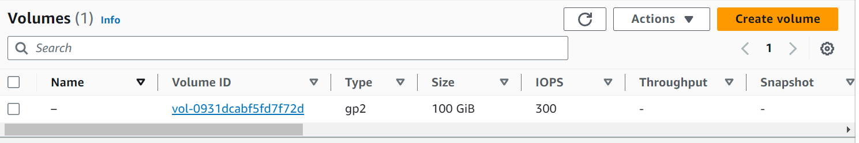

2.After Refreshinig the Page

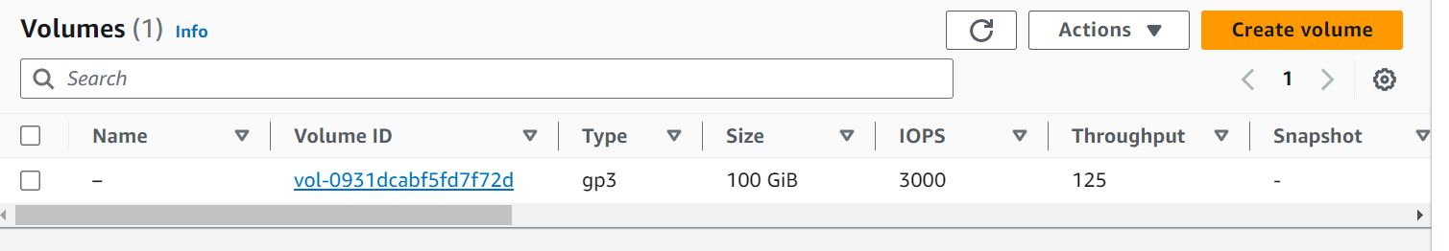

Finally It is Changed the type of EBS Volume

**Note:**

i. If any error occur during Execution GO to Log groups in the Cloud watch ,find LATEST Log ,try to fix the error and Execute means Create EBS Volume

ii. Give the least Privilege Permissions to Iam role